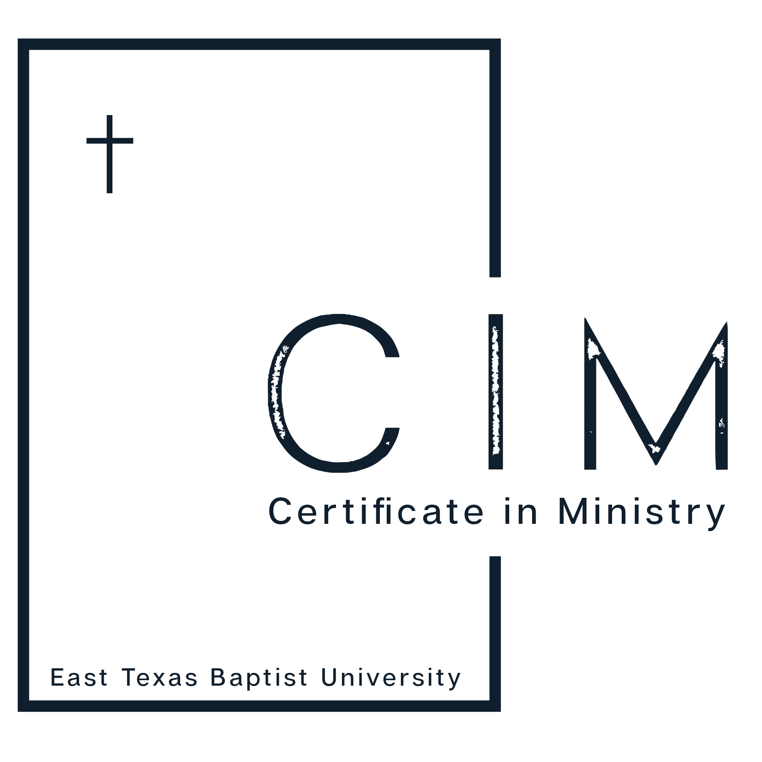
COMPLETION INTERVIEW PROTOCOL FORM

Instructions: conduct a personal interview in person or by phone with each student within 2 weeks of their completion of the CIM program. When asking the following questions and completing this form, draw the student out to help you discover areas of strength, concern, and possible improvements. Additional departmental questions may be added.

General Information

Name: Program: CIM
Semester/year of completion:

Quality of Experience Questions

- How satisfied are you with the learning in the CIM program?

Very Satisfied/Satisfied/Not satisfied.
Ask for further explanation of the answer:

- How satisfied are you with the facilities and equipment provided in the CIM program?

Very Satisfied/Satisfied/Not satisfied.
Ask for further explanation of the answer:

- How satisfied are you with the faculty in the CIM program?

Very Satisfied/Satisfied/Not satisfied.
Ask for further explanation of the answer:

- How satisfied are you are with the curriculum of the CIM program?

Very Satisfied/Satisfied/Not satisfied.
Ask for further explanation of the answer:

- Do you plan to continue your education by enrolling in an undergraduate program?

Yes/No
Ask for further explanation of the answer:

