How to Add the ETBU Home Page to Your Courses in Canvas

1. Go to your course and click on Home.
2. Click on “Import from Commons”
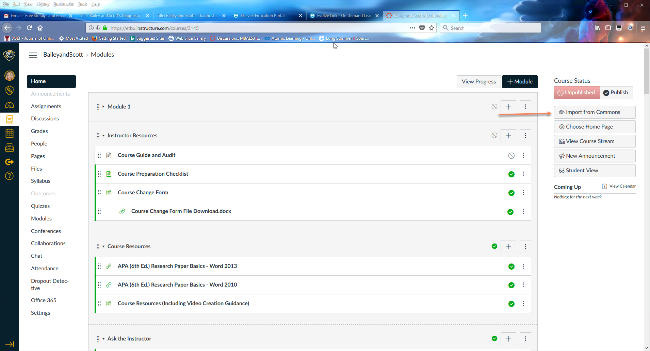
3. You can turn off “Public Resources” so the home page will be easier to find. Type “ETBU” in the search bar. Click Enter.
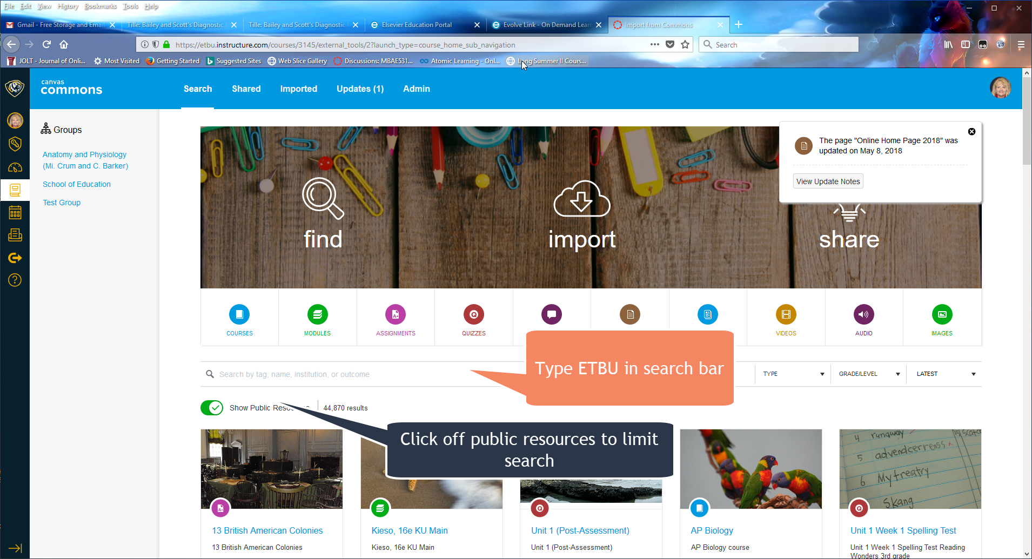

4. Select F2F Home Page

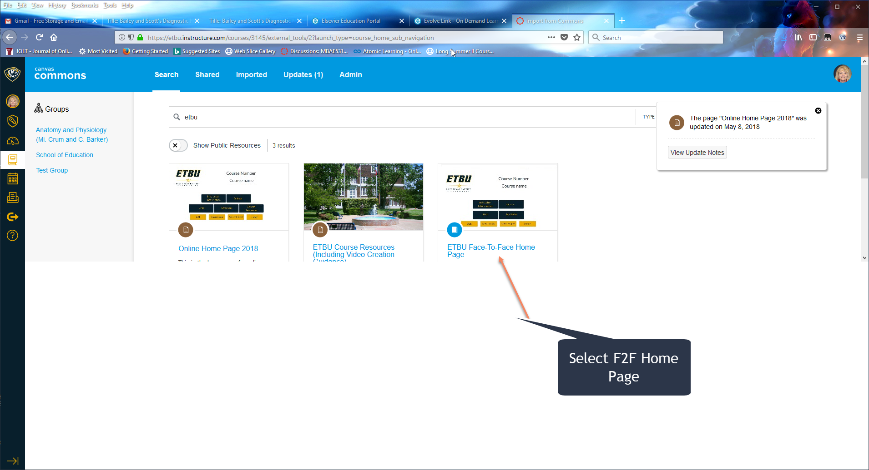

5. Go to “Import into Canvas” on the left. Click the box on the course you want to place the home page in and click “Import into Course.” It may take a few minutes before it shows up in the courses.
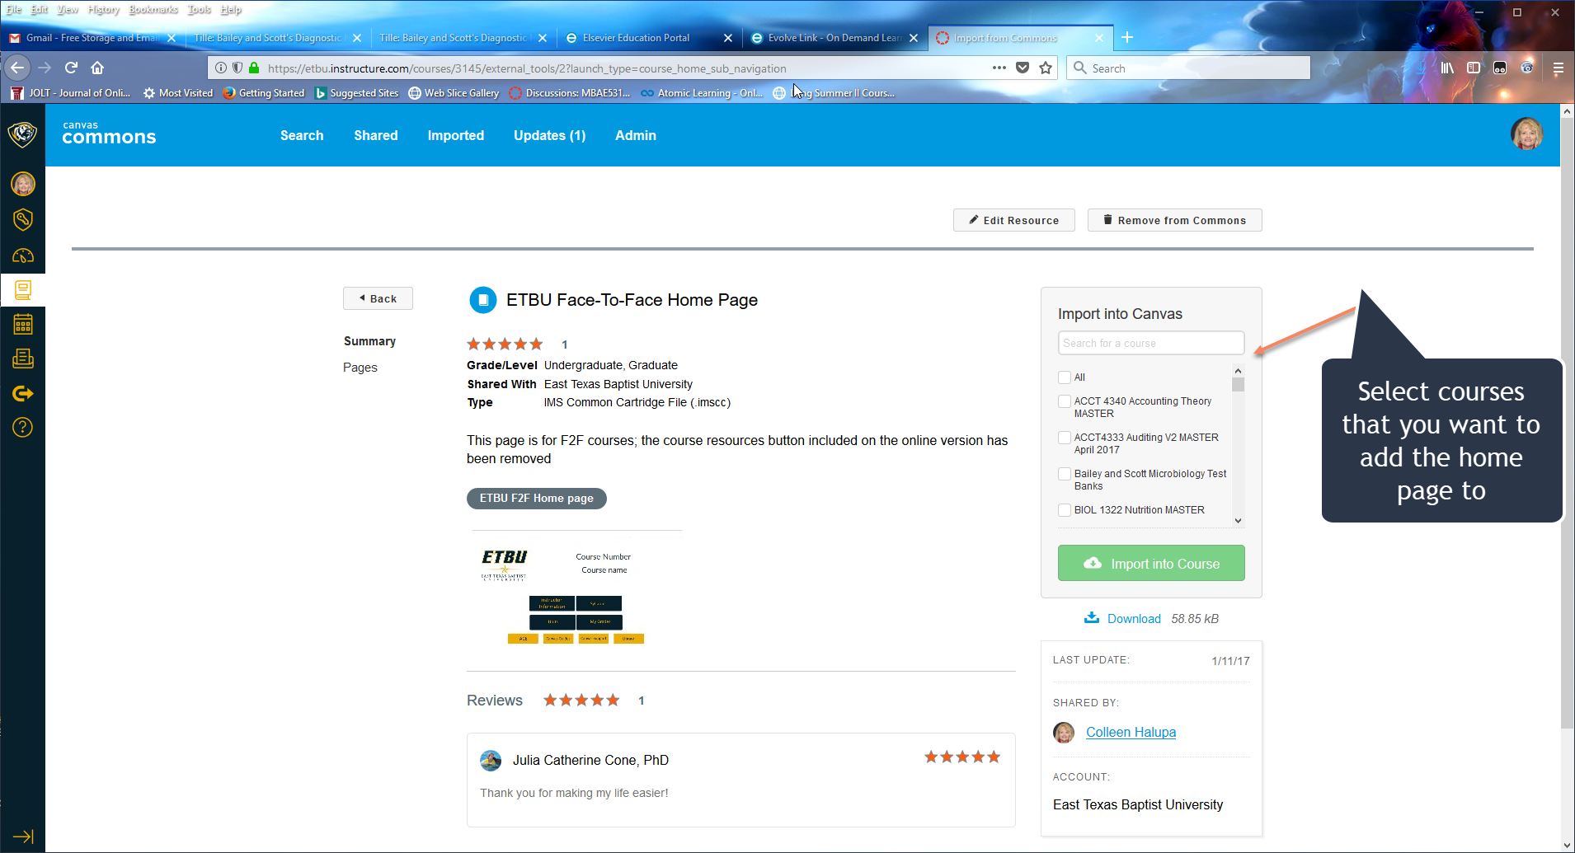

6. The home page may automatically appear on the home screen on your course. Clock Edit to change course name and number.
If the home page is not there, go to your course and click on “Choose Home Page.” Click on ‘Pages” and then look for the home page file and select it.
